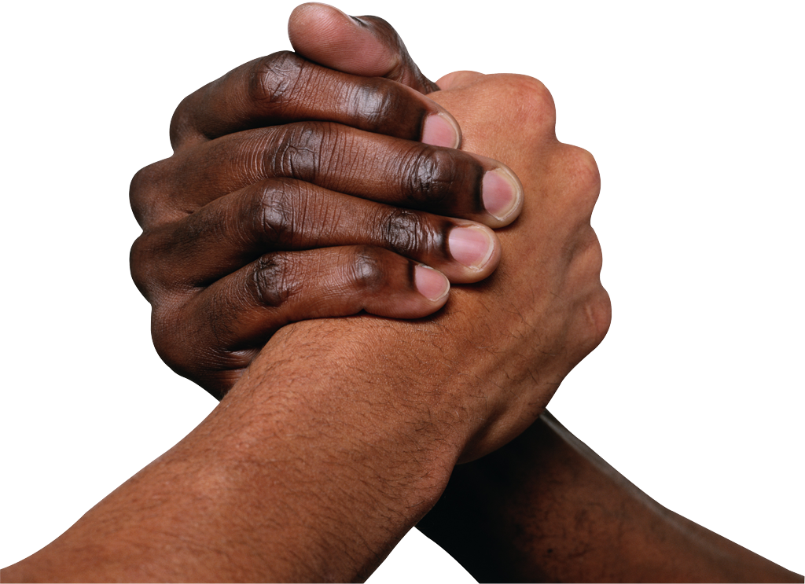
What’s a Humanist?
Due: Thursday, November 24, 2016
Either individually, or in groups of no more than 3 people, you will be creating a presentation that explains what humanism is. Your presentation will need to answer the following questions:
- What is humanism?
- What are the characteristics of humanism?
- Who today would you consider a humanist?
- Why?
- What characteristics of a humanist are they exhibiting?
You can create a presentation of your choosing that best exhibits your ideas. Ex. Create a Movie, PowerPoint, Emaze, Poster or any other form approved by the teacher.
You will be presenting your presentation as a group on Thursday, November 24, 2016.
Concept:  - The concept of humanism is clearly explained | 1 2 3 4
Characteristics:  - The characteristics of humanism are clearly explained and identified | 1 2 3 4
Connection and Application (x2)  - Students are able to connect their understanding of humanism and the characteristics to a modern day person.  - It is clearly explained how that person exhibits characteristics of humanism and what characteristics that person displays | 1 2 3 4
Communication: (x2)  - Groups is able to clearly communicate their findings  - Group is able to speak clearly and engage the audience  - Medium chosen is suitable to explain the content  - Group is able to answer questions appropriately regarding the topic | 1 2 3 4
/24
Brainstorming
Name(s): _________________________________________________________________________________
Type of project: _____________ Materials Needed:_______________________________________________
What is humanism? ____________________________________________________________________________________________________________________________________________________________________________________
What are the characteristics of humanism?
1. ________________________________________________________________________________________
Explain: ___________________________________________________________________________________
2. ________________________________________________________________________________________
Explain: ___________________________________________________________________________________
3. ________________________________________________________________________________________
Explain: ___________________________________________________________________________________
4. ________________________________________________________________________________________
Explain: ___________________________________________________________________________________

Who is someone that exhibits these characteristics today?
Name: ____________________________________________________________________________________
Why? What did they do? _____________________________________________________________________
____________________________________________________________________________________________________________________________________________________________________________________
____________________________________________________________________________________________________________________________________________________________________________________
____________________________________________________________________________________________________________________________________________________________________________________
____________________________________________________________________________________________________________________________________________________________________________________
What humanist characteristics do they exhibit? ___________________________________________________
____________________________________________________________________________________________________________________________________________________________________________________
____________________________________________________________________________________________________________________________________________________________________________________

